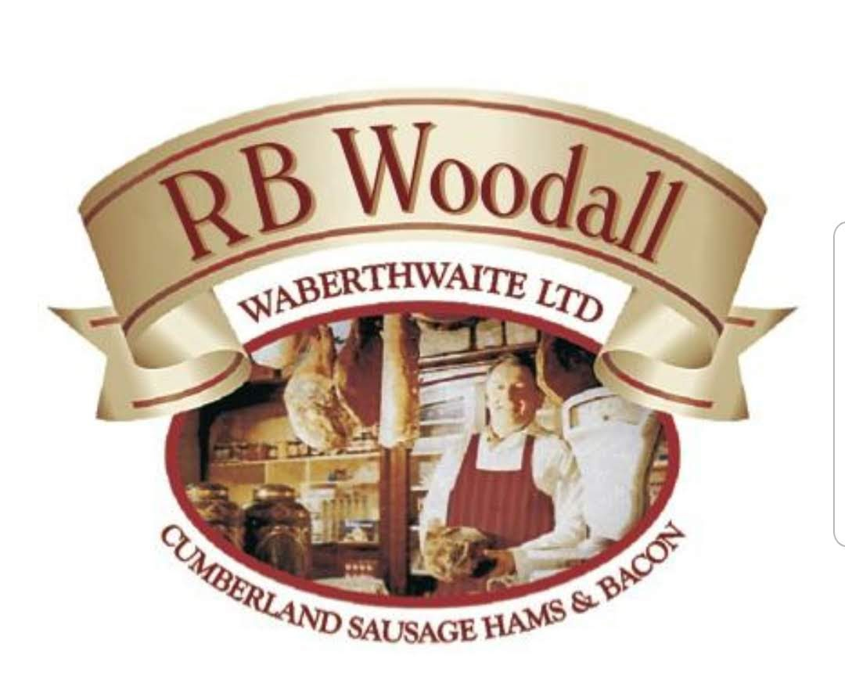

R B Woodall Ltd
RETAIL PRICE LIST
Tel 01229717237
Email info@rbwoodall.co.uk

PANCETTA
200g Diced £4.89 each
100g Sliced £3.40 each
COUNTRY CURE BACON
Rindless Unsmoked back sliced 200g £3.80 each
Rindless smoked back sliced 200g £3.95 each
CUMBERLAND BACON (UNSMOKED)
Middle 200g £4.02 each
Short back 200g £4.02 each
Streaky 200g £4.02 each
CUMBERLAND BACON (SMOKED)
Middle 200g £4.11 each
Short back 200g £4.11 each
Streaky 200g £4.11 each

Black pudding
Black pudding slices £5.70 per kg
Stornoway Black pudding slices £16.10 per kg

Traditional Waberthwaite Cumberland Sausage
Thick sausage 400g £5.37 each
Thick sausage 200g £2.78 each
Thick Link Sausage 400g £5.37 each
Thick sausage £11.35 per kg

Country Sausage
Thick country sausage £10.90 per kg

Smoked Gluten free sausage £13.35 per kg

PRICES ARE SUBJECT TO CHANGE

